Instructions for Taking a Vaginal STI Test
You have requested a home test for one or more STIs. You have received a collection kit to perform the test. This instruction sheet will explain how to take the sample at home and what to do afterwards.
The collection process is very simple and takes only a few minutes. In this collection kit you will find:
- A swab
- A collection tube
- A sealable bag with an absorbent sheet
- A laboratory request form
- A return envelope
Follow these steps to take the sample:
Wash your hands thoroughly with water and soap, and dry them well. |  | 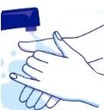
Open the swab packaging by peeling back the foil on the side. Hold the swab by the handle and remove it from the packaging. Do not touch the tip of the swab. |  | 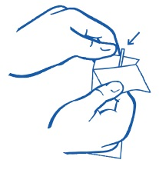
Insert the swab carefully about 3 cm into your vagina. Rotate the swab a few times (3 to 5 times) to collect enough material. |  | 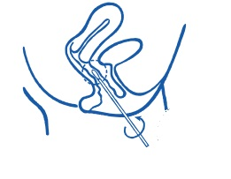
Remove the swab carefully and place it in the collection tube. Break off the excess part of the swab handle if needed and close the tube tightly with the cap. |  | 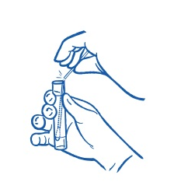
You have now completed the sample collection. Next, you need to send the tube back to the laboratory for analysis. Follow these steps:
- Fill out the laboratory form that you received.
- Enter your date of birth, gender, and the date of sample collection.
- Place the tube and the absorbent sheet in the sealable bag provided. Seal the bag properly. Include the laboratory form in the sealable bag inside the return envelope.
- Send the return envelope to the laboratory as soon as possible via a PostNL mailbox or PostNL service point. No postage stamp is needed; the envelope is already pre-paid.
- You will receive your results within 10 working days from the requesting company. They can also provide guidance if your test is positive for an STI.
We hope these instructions have helped you take the test at home. If you have any questions about STIs or the test, you can contact us. Otherwise, we wish you good health.

